Bahria University,

Karachi Campus



LAB EXPERIMENT NO.

01

LIST OF TASKS

|  |  |
| --- | --- |
| TASK NO | OBJECTIVE |
|  |  |
| 1 | Take two inputs and Subtract. |
| 2 | To take two hardcoded input and Add them. |
|  |  |
|  |  |
|  |  |
|  |  |
|  |  |
|  |  |
|  |  |
|  |  |
|  |  |
|  |  |
|  |  |
|  |  |

Submitted On:

01/10/2019

(Date: DD/MM/YY)

# **TASK NO 1:**

Take two inputs and Subtract.

# **Solution:**

IN

STO 90

IN

SUB 90

OUT

HLT

## **OUTPUT:**

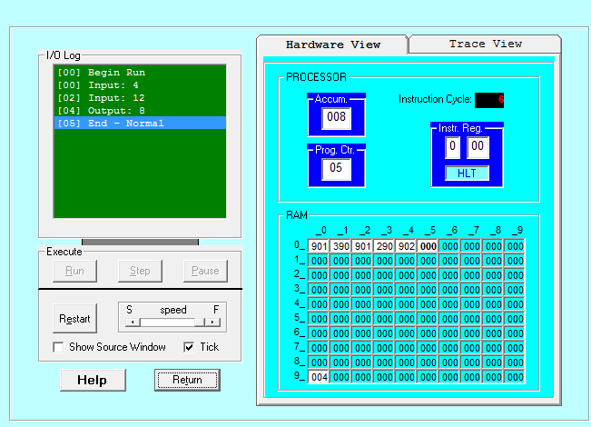

# **TASK NO 2:**

Take two hard coded inputs and add them.

# **Solution:**

LDA 90

ADD 91

OUT

HLT

*90

DAT 012

DAT 008

## **OUTPUT:**

